**P235/3**

**ISLAMIC RELIGIOUS**

**EDUCATION**

**(History of Islamic**

**Civilization)**

Paper 3

Jul/Aug 2019

2 ½ Hours

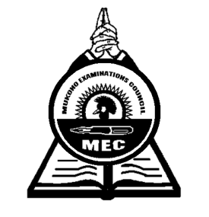

**MUKONO EXAMINATION COUNCIL**

**Uganda Advanced Certificate of Education**

**ISLAMIC RELIGIOUS EDUCATION**

**(History of Islamic Civilization)**

Paper 3

2 Hours 30 Minutes

**INSTRUCTIONS TO CANDIDATES**

*Answer any* ***four*** *questions.*

***All*** *questions carry equal marks*

*Any additional questions(s) answered will* ***not*** *be marked.*

1. Analyze the social, moral and economic life of the pre-Islamic Arabs that did not reflect the element of religion. ***(25 marks)***
2. To what extent did the Covenant f 628AD lead to the Triumph of Prophet Muhammad’s (p.b.u.h) mission? ***(25 marks)***
3. Discuss the social and political strengths of Umar Bin Khattab in the period 636AD – 644AD.

***(25 marks)***

1. Assess the contribution of Caliph Suleiman’s successor towards the consolidation of the Ummayyads rule. ***(25 marks)***
2. Analyze the political and social organization of the Ummayyads. ***(25 marks)***
3. Assess the performance of Abbasid Dynasty to the development of Islam. ***(25 marks)***
4. a) Account for the delayed expansion of the Fatimid in Maghreb region. ***(13 marks)***

b) Explain their contributions to the people of Maghreb region. ***(12 marks)***

1. Discuss the economic development and intellectual growth of the Fatimids. ***(25 marks)***
2. Discuss the causes and effects of the crusade movements of 11 – 13 centuries. ***(25 marks)***
3. a) Discuss the factors for the emergence of the Safavids in Persia. ***(12 marks)***

b) Analyze the contribution of the Safavids to the development of Islam. ***(13 marks)***

1. Examine the Ottoman organization called “tanzimat”. ***(25 marks)***
2. Discuss the changes exhibited in the development of Ottoman empire in the period of 1520 – 1566. ***(25 marks)***

***End -***